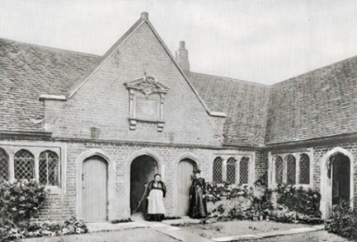
Amersham United Charities

The Clerk

Amersham United Charities

St. Mary's Church Parish Office

10 Church Street

Amersham HP7 0DB

Charity Commission Registered No. 205033

Email: clerk@amershamalmshouses.org.uk
EXPRESSION OF INTEREST FORM
Amersham United Charities provides housing at Drake’s almhouses and Miss Day’s almshouses in Old Amersham for people in need in accordance with the Charity’s Governing Document. If you are interested in becoming a resident, you can register your interest by providing the information requested below and returning the completed form by post or email to the Clerk.
When an almshouse becomes available, the Charity will send you a detailed Application Form to complete. All applications are reviewed by the Charity’s Trustees who are responsible for ensuring that applicants for an almshouse are suitably qualified. Please note that the submission of this Expression of Interest Form and the date on which is it received do not provide priority for an applicant over any other applicants.
The Charity’s eligibility criteria for a resident to be considered for an appointment to an almshouse are that the person must be of limited financial means; single or divorced or widowed; and resident at the time of their appointment in one of the areas listed below in the following order of priority:
  - the area of benefit (the parishes of Amersham and Coleshill); or
  - the ancient parish of the Lee; or
  - the surrounding area.
In addition to observing the above criteria, the Trustees should give priority to members of the Church of England when appointing residents to Miss Day's almshouses.
Your full name including title

Current address

Email address

Telephone number

Date of Birth

Marital Status

Data Protection Statement: The Charity complies with the regulations for data security under the Data Protection Act 2018 and UK General Data Protection Regulations (UK GDPR). The data we collect has been classified as Sensitive Data under Article 9 of UK GDPR. We have strong procedures and policies in place to protect the collection and storage of this data. The personal data supplied on this form will be held on paper and as an electronic file. This information will only be used to contact you in the event that a vacancy occurs. You can request that your details are withdrawn at any time by contacting the Clerk and you may have access to your personal information on request.

v. 082026

